Alexandra Stella, Amaris Velasquez, Katherine Dumangas, Stewart Dulaney, Xicalli Garcia

MATH 54

Summer 2018

Section 4053

**MATH 54 Project - Prompt #1**

**Introduction:**

We prompted our assignment with the question: Would it be cheaper to be an English major or a History major at Santa Monica College (SMC)? Curious to find the answer, we compared the prices of 15 history books and 15 english books to determine if either were drastically more expensive. We collected our data using english and history textbooks from the SMC Bookstore and recorded our findings using graphs and tables to explain our research question. Then we plotted the variations in prices versus the number of pages per book to illustrate trends in the cost of books for each distinct major. Leading up to ask the question: Is there a linear relation between price and the number of pages per textbook?

Here is the raw data collected below for fifteen English books:

|  |  |  |
| --- | --- | --- |
| English Book | # of pages | Price ($) |
| 1 | 1997 | 147.25 |
| 2 | 1900 | 73.25 |
| 3 | 1700 | 105.00 |
| 4 | 1354 | 69.50 |
| 5 | 946 | 71.25 |
| 6 | 165 | 15.00 |
| 7 | 1128 | 88.50 |
| 8 | 89 | 12.95 |
| 9 | 127 | 35.50 |
| 10 | 1742 | 139.50 |
| 11 | 1976 | 90.75 |
| 12 | 298 | 20.00 |
| 13 | 332 | 16.00 |
| 14 | 1570 | 114.75 |
| 15 | 355 | 86.00 |

Based on our collected raw data, the graph below represents english textbooks. The x-axis (also the explanatory variable) represents the price per english textbook, while the y-axis (the response variable) is the number of pages per english textbook. In this particular graph, the slope and y-intercept are positive.

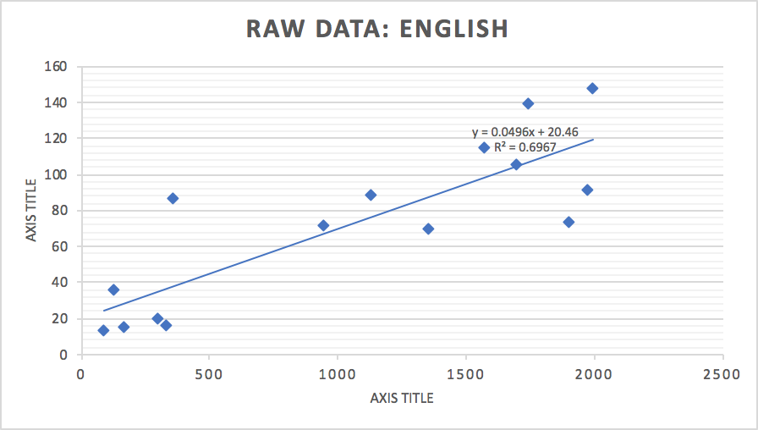

Here is the recorded raw data for fifteen history textbooks:

|  |  |  |
| --- | --- | --- |
| History Book | # of pages | Price ($) |
| 1 | 330 | 31.25 |
| 2 | 380 | 54.25 |
| 3 | 515 | 18.00 |
| 4 | 1150 | 67.75 |
| 5 | 322 | 67.75 |
| 6 | 536 | 132.25 |
| 7 | 565 | 162.75 |
| 8 | 315 | 49.00 |
| 9 | 490 | 122.00 |
| 10 | 1090 | 118.25 |
| 11 | 298 | 30.00 |
| 12 | 720 | 100.50 |
| 13 | 460 | 30.00 |
| 14 | 296 | 187.25 |
| 15 | 559 | 73.50 |

Based on our collected raw data, the graph below represents history textbooks. The x-axis (also the explanatory variable) represents the price per history textbook, while the y-axis (the response variable) is the number of pages per history textbook. In the graph shown below, we found no linear correlation between the number of pages per history textbook and the prices. The regression line was less than 0.5.

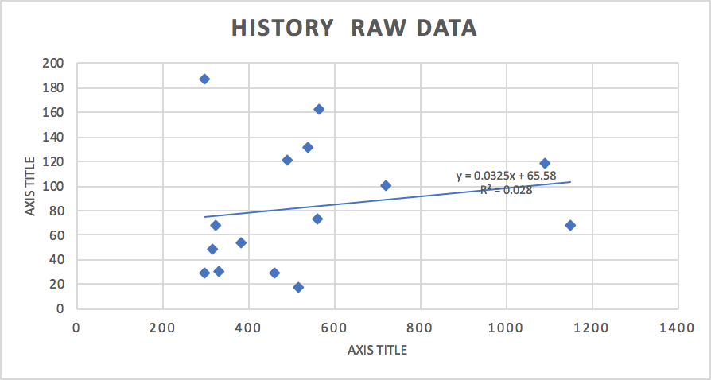

Based on our raw data, we found these outliers:

English raw data outliers:

IQR= Q3 - Q1, Q3= 105, Q1=20

105 - 20= 85 =IQR

Lower Fence: LF= Q1 - 1.5(IQR)

20 - 1.5(85)= -107.5

Upper Fence: UF= Q3 + 1.5(IQR)

105 + 1.5(85)= 232.5

History raw data outliers:

IQR= Q3 - Q1, Q3= 122, Q1=31.25

122 - 31.25= 90.75 =IQR

Lower Fence: LF= Q1 - 1.5(IQR)

31.25 - 1.5(90.75)= -104.875

Upper Fence: UF= Q3 + 1.5(IQR)

122 + 1.5(90.75)= 258.125

We also calculated the frequencies of both history and english books in the tables shown below accompanied by graphs and histograms to answer our research question, “Is there a linear relation between price of textbooks and page numbers?”:

|  |  |  |
| --- | --- | --- |
| Price ($) | History Books Frequency | English Books Frequency |
| 0-20 | 2 | 4 |
| 21-40 | 2 | 1 |
| 41-60 | 4 | 0 |
| 61-80 | 1 | 3 |
| 81-100 | 0 | 3 |
| 101-120 | 2 | 2 |
| 121-140 | 2 | 1 |
| 141-160 | 1 | 1 |
| 161-180 | 0 | 0 |
| 181-200 | 1 | 0 |

In this graph, the slope of the line is negative. The line also shows a negative association.

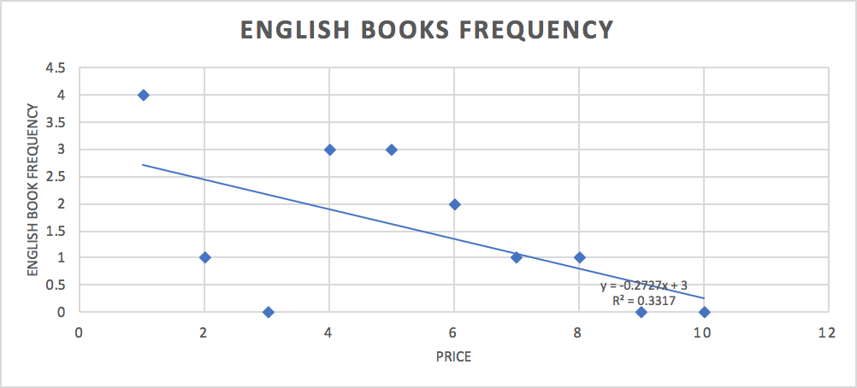

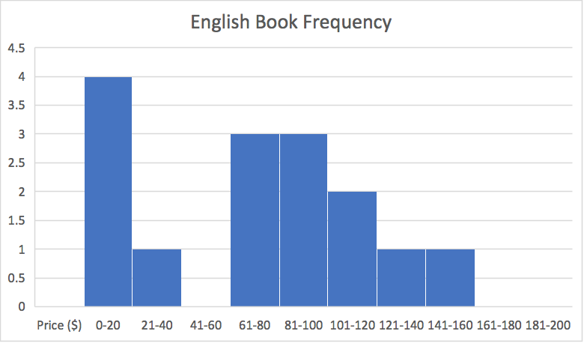

The histogram above does not show a normal bell-shaped curve.

The slope of this graph for history books is negative.

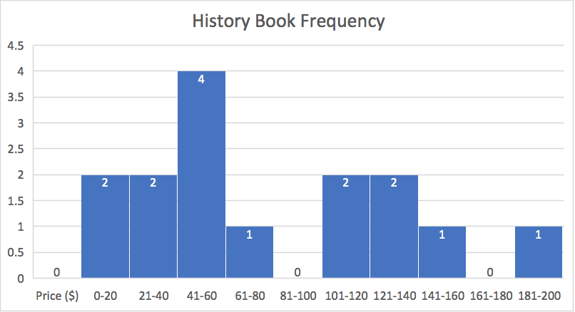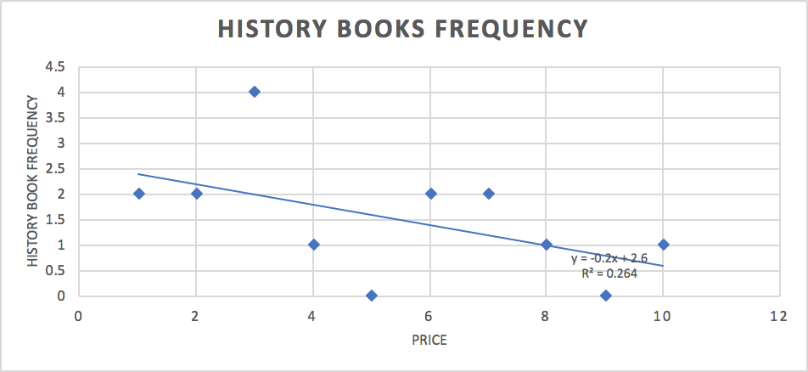

The frequency graph above for history books does not show a normal bell-shaped distribution.

This table below represents the relative frequencies calculated for both history and english textbooks followed by relative frequency graphs and histograms:

|  |  |  |
| --- | --- | --- |
| Price ($) | History Books  Relative Frequency | English Books  Relative Frequency |
| 0-20 | .1333 | .2667 |
| 21-40 | .1333 | .0667 |
| 41-60 | .2667 | 0 |
| 61-80 | .0667 | .2 |
| 81-100 | 0 | .2 |
| 101-120 | .1333 | .1333 |
| 121-140 | .1333 | .0667 |
| 141-160 | .0667 | .0667 |
| 161-180 | 0 | 0 |
| 181-200 | .0667 | 0 |

Based on this graph, there is no indication of a positive linear association.

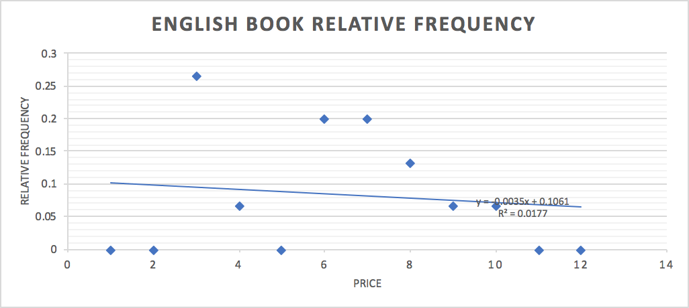

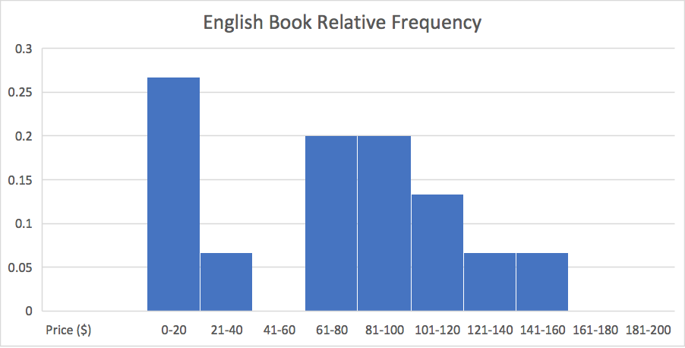

Based on this relative frequency graph, there is no normal bell-shaped distribution.

This relative frequency graph for history textbooks shows no positive linear correlation.

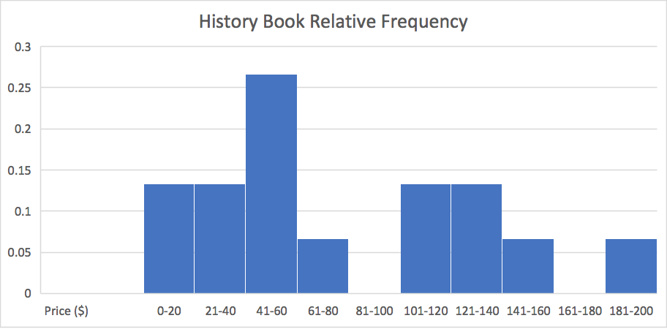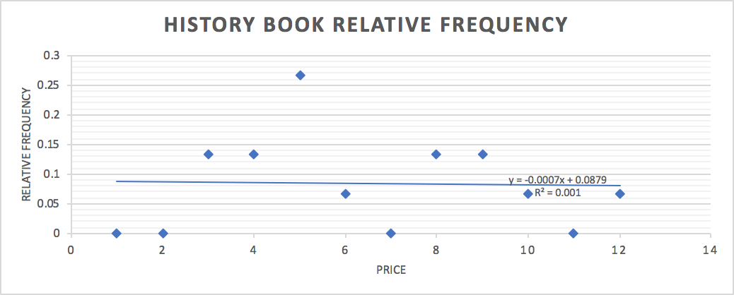

This relative frequency graph does not show a normal bell shaped curve.

Based on our findings, we concluded that there is no linear relation between the number of pages per textbook and the cost per textbook when analyzing the frequency graphs. However, we found that increasing our sample size to more than 30 textbooks allowed us to perform a hypothesis test. Our original research question was, “Is it cheaper to be an English major than a History major?” After conducting a hypothesis test, we concluded that history textbooks were more expensive than english textbooks. The results of our hypothesis test are found below.

To test whether it is cheaper to be an English major than a History major, we gathered a random sample of 30 english textbooks and a second random sample of 30 history textbooks from the SMC Bookstore. The study resulted in the following prices (in U.S. dollars):

|  |  |  |  |  |  |  |  |  |  |  |  |
| --- | --- | --- | --- | --- | --- | --- | --- | --- | --- | --- | --- |
| English textbooks | | | | | | History textbooks | | | | | |
| 12.95 | 69.50 | 90.75 | 84.00 | 47.50 | 16.00 | 18.00 | 54.25 | 122.00 | 13.00 | 74.50 | 50.00 |
| 15.00 | 71.25 | 105.00 | 11.99 | 6.00 | 17.00 | 30.00 | 67.75 | 132.25 | 84.00 | 67.75 | 177.00 |
| 16.00 | 73.25 | 114.75 | 65.50 | 20.75 | 17.00 | 30.00 | 67.75 | 162.75 | 54.25 | 67.75 | 63.00 |
| 20.00 | 86.00 | 139.50 | 17.00 | 88.50 | 85.50 | 31.25 | 100.50 | 14.00 | 69.00 | 19.25 | 187.25 |
| 35.50 | 88.50 | 147.25 | 38.50 | 90.75 | 9.00 | 49.00 | 118.25 | 14.00 | 54.25 | 55.50 | 73.50 |

We can perform a hypothesis test regarding $μ_{1}$, the population mean price of English textbooks and $μ_{2}$, the population mean price of History textbooks provided that:

1. The samples are obtained using simple random sampling ✔
2. The samples are independent ✔
3. The sample sizes are large ✔ (${n_{1}≥30}_{}$ and ${n_{2}≥30}_{}$)
4. For each sample, the sample size is no more than 5% of the population size:
   1. $n_{1}≤0.05N_{1}$ ✔ (there are at least 1,000 different English textbooks)
   2. $n_{2}≤0.05N_{2}$ ✔ (there are at least 1,000 different History textbooks)

Using Excel, we obtained the following summary statistics:

${{\underline{x}}_{1}=56.673, s_{1}=7.6039, n_{1}=30, }_{}{{\underline{x}}_{2}=70.725, s_{2}=8.6581, n_{2}=30 }_{}$

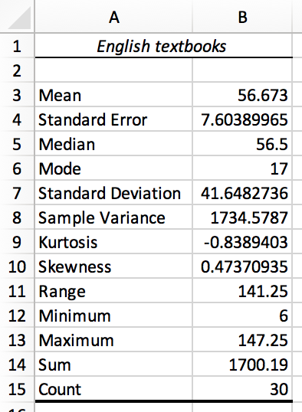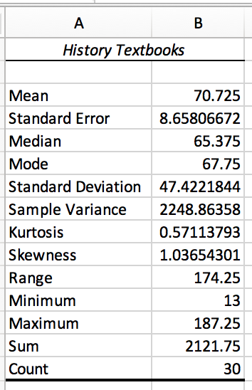

Step 1) State hypotheses:

$H_{0}: μ_{1}={μ_{2}}_{}$

$H_{1}: μ_{1}<{μ_{2}}_{}$ (left-tailed)

Step 2) Select a level of significance:

$α=0.05$

Step 3) Compute test statistic and critical value:

Classical Method:

$t_{0}=\frac{{\underline{x}}_{1}-{\underline{x}}_{2}}{\sqrt{\frac{s_{1}^{2}}{n_{1}}+\frac{s_{2}^{2}}{n_{2}}}}=\frac{56.673 -70.725 }{\sqrt{\frac{{7.6039}^{2}}{30}+\frac{{8.6581}^{2}}{30}}}=-6.679$

$df = n_{1}-1=30-1=29$

${-t}_{α}=-t_{0.05}=-1.699$

Step 4) Compare the critical value to the test statistic:

$t_{0}<-t_{α}?$

$-6.679 <-1.699$ ✔

Therefore, reject the null hypothesis.

Step 5) State the conclusion:

There is sufficient evidence at the $α=0.05$ level of significance to conclude that the population mean price of English textbooks is less than the population mean price of History textbooks.

**Conclusion:**

Overall, the data we collected was quantitative and discrete. We also selected books randomly in the bookstore. The study was observational since we measured the value of the response variable (books) without attempting to influence the value of either the response or explanatory variables (prices of books). Since our study was observational, we cannot claim causation, only association. We recognize there are confounding and lurking variables which may have affected our research. Some examples of confounding variables include size of books, weight of books, publishers of the books, and type of paper used to print the pages which could affect the pricing. Examples of lurking variables include the time and day we gathered the data at the bookstore. Sometimes, the bookstore offers discounts or deals on textbooks, and we went on a day where there were no promotions or discounts. After analyzing our data, we concluded that we needed a larger sample to work with since we found no linear correlation between the number of pages and pricing. Once we gathered additional books, we utilized the hypothesis test to answer our second question, and found that history books are more expensive than english books. Based on the results, it would be more expensive to be a history major than an english major at SMC.